ANIMATRONICS FACE: PROFESSOR XIAODU WANG

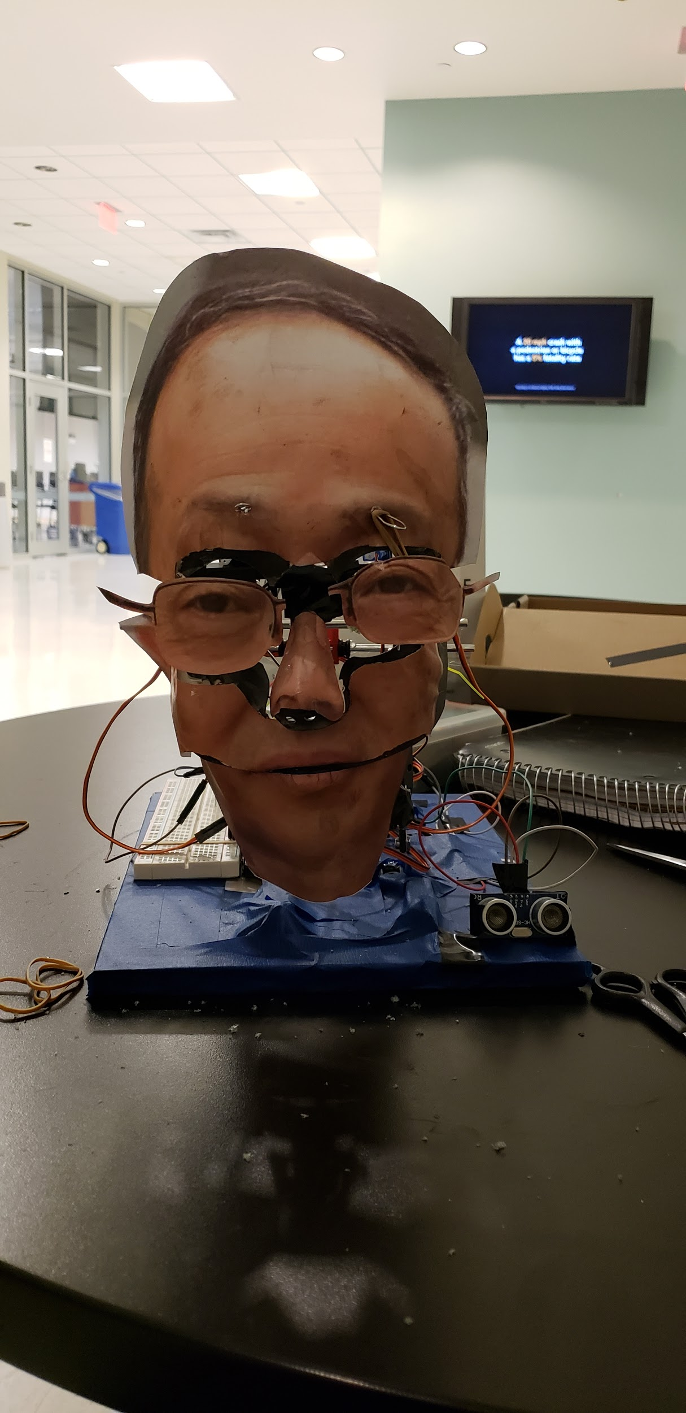

Yisvi Aroche

Dept. of Mechanical Engineering

San Antonio, TX, USA 78249

zbi713@my.utsa.edu

Tiraja Blake

Dept. of Mechanical Engineering

San Antonio, TX, USA 78249

tiraja822@gmail.com

Evangeline Tuason

Dept. of Mechanical Engineering

San Antonio, TX, USA 78249

evangelinetuason@gmail.com

Submitted as part of project for ME 4543 Mechatronics, Fall 2018

TABLE OF CONTENTS

|  |  |
| --- | --- |
| Abstract | 3 |
| Literature Review | 4 |
| Supporting Structure | 5 |
| Joints and Motors | 6 |
| Sensors | 7 |
| Programming | 7 |
| Lesson learnt and suggestions | 8 |
| Personnel and Bill of Materials | 9 |
| References | 10 |
| Appendix A: Code | 11 |
| Appendix B: Arduino wiring | 13 |
| Appendix C: Example Codes for push button and ultrasonic sensors | 14 |

**ABSTRACT**

This report goes into detail of the processes that were taken in order to create an animatronic face of Dr.Wang. The head was created by using and erector set, face mask, and picture of his face to create the base structure. The motion of his eyes, eyebrows, and mouth were driven from servo motors that were activated through the use of an ultrasonic sensor or a contact button sensor, as well as speaking from a MP3 through speakers. These were powered by use of an Arduino MEGA 2560 board. The walkthrough of the creation is listed below.

**Section 1: Literature review**

The animatronic face as seen in figure 1, utilizes advanced hardware and software to create a humanoid robot from a premade mannequin head. From reading their project report [1], the creators attributed a reduction in time spent on trial-and-error for programming the robot from their use of face tracking software. Which provided a faster way of achieving the eight degrees of freedom that the creators applied to the animatronic face. They converted the information received from the tracking software using MATLAB and then created the performance script using Visual Show Automation. The hardware applied for this project included an intricate system of actuators and linking systems, these were driven by a multitude of servos to achieve the degrees of freedom. A Mini SSCII motor controller was used to send the servos commands instead of sensors.

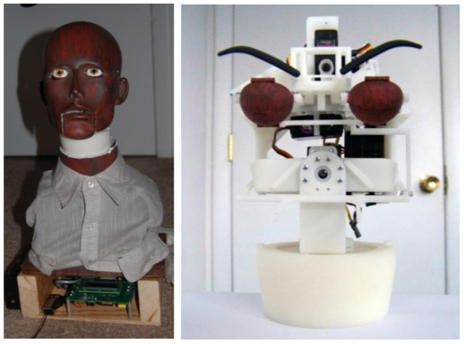

**Figure 1: Animatronic Face Utilizing Face-Tracking Software**

The animatronic talking head as seen in figure 2 can be recreated following the instructable posted in the link provided [2]. The rudimentary face shape and structure was provided from a plywood profile, latex lips, and doll eyes. Code downloaded from a computer onto a RAPU provided commands to the Mini SSCII servo controller which translates the code into physical servo movements, an external power supply is attached to the controller. The servos drove different movements on the face for the up-and-down motion of the mouth, eyes, and eyebrows. Computer speakers were utilized for the output of the text-to-speech from a Word document to an mp3 file.

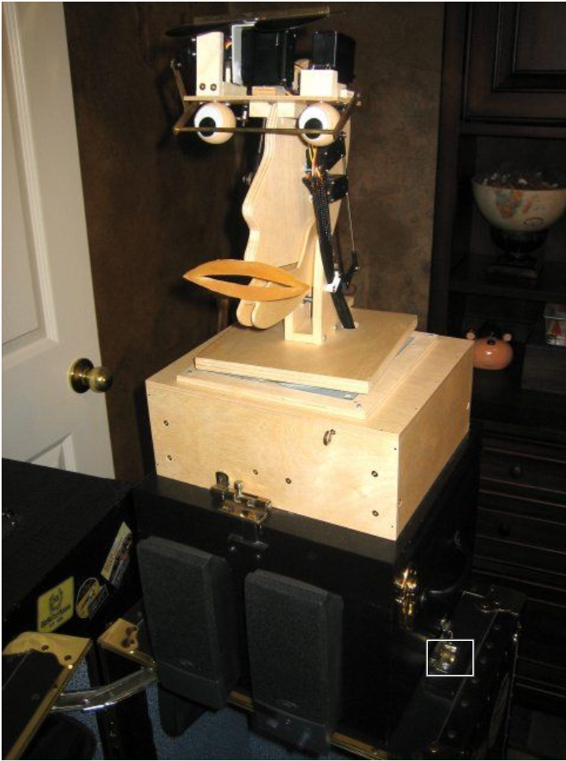

**Figure 2: Talking Animatronic Head**

The inexpensive animatronic face intended for a humorous upgrade for a modular synth is a grotesque resemblance of a human face, as seen in figure 3, that is simple in structure yet impressive in its articulate motion. The creation of ‘Kosmo’ can be followed along through an instructional YouTube [3]. Taking advantage of scraps the eyes were constructed from ping pong balls, driven by 2 servo motors each, chattering teeth provided the mouth movement driven from a single servo, another servo drove the eyebrow motion. A Teensy 3.2 was picked for its capability of having more post for modulation pins, to give commands to the motors.

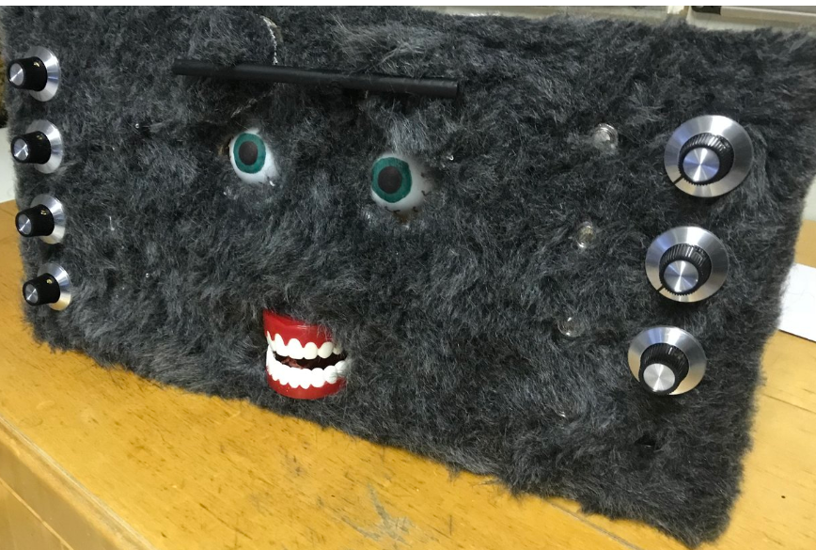

**Figure 3: Kosmo The Modular Synthesizer**

**Section 2: Brainstorming (initial planning)**

Group 5 has been given Dr.Wang to create an animatronic face of.It was decided that the three separate movements were to be the mouth (lower jaw goes up and down), eyes (move left and right), eyebrows/glasses (move up and down). These movements would be driven by the use of servos. Because the animatronics will be autonomous once engaged sensor will be utilized to tell the servos when to move: ultrasonic to sense presence of someone then start talking, a button contact sensor will raise the eyebrows and eyes will move around if the nose is booped. The components will be held in place by the use of an erector set structure. For the proper resemblance of Dr.Wang an image of his face will be printed and put on top of a simple face mask. The face will sing in Mandarin or tell us a fun fact about himself as well as introduce himself, the audio will be an actual recording of Wang that will be recorded on a phone and converted to an MP3 clip that will be played over the computer that is powering the face.

**Section 3: Supporting structure**

The supporting structure was created using parts from an erector set. A solid base was constructed and then two main support beams come up from the base. From which a mechanical mandible and two square eye sockets are braced. A beam going across the top connects the two support beams to create a more stable structure as well as providing the skeletally speaking, top of the animatronic head. Protruding from the top of the head are two rods; representing Dr.Wang’s glasses. Besides the basic mainframe, the other features were attached because we needed a place to set his feature that will be in motion.

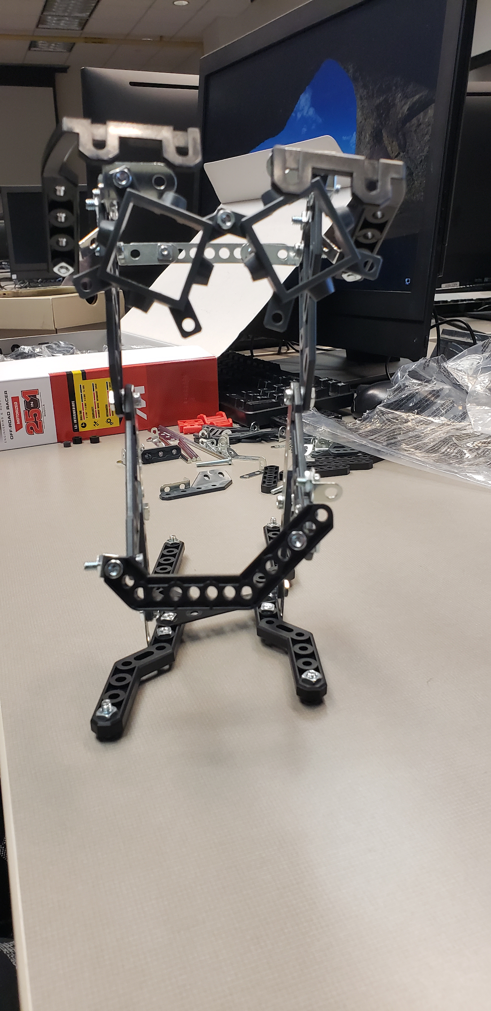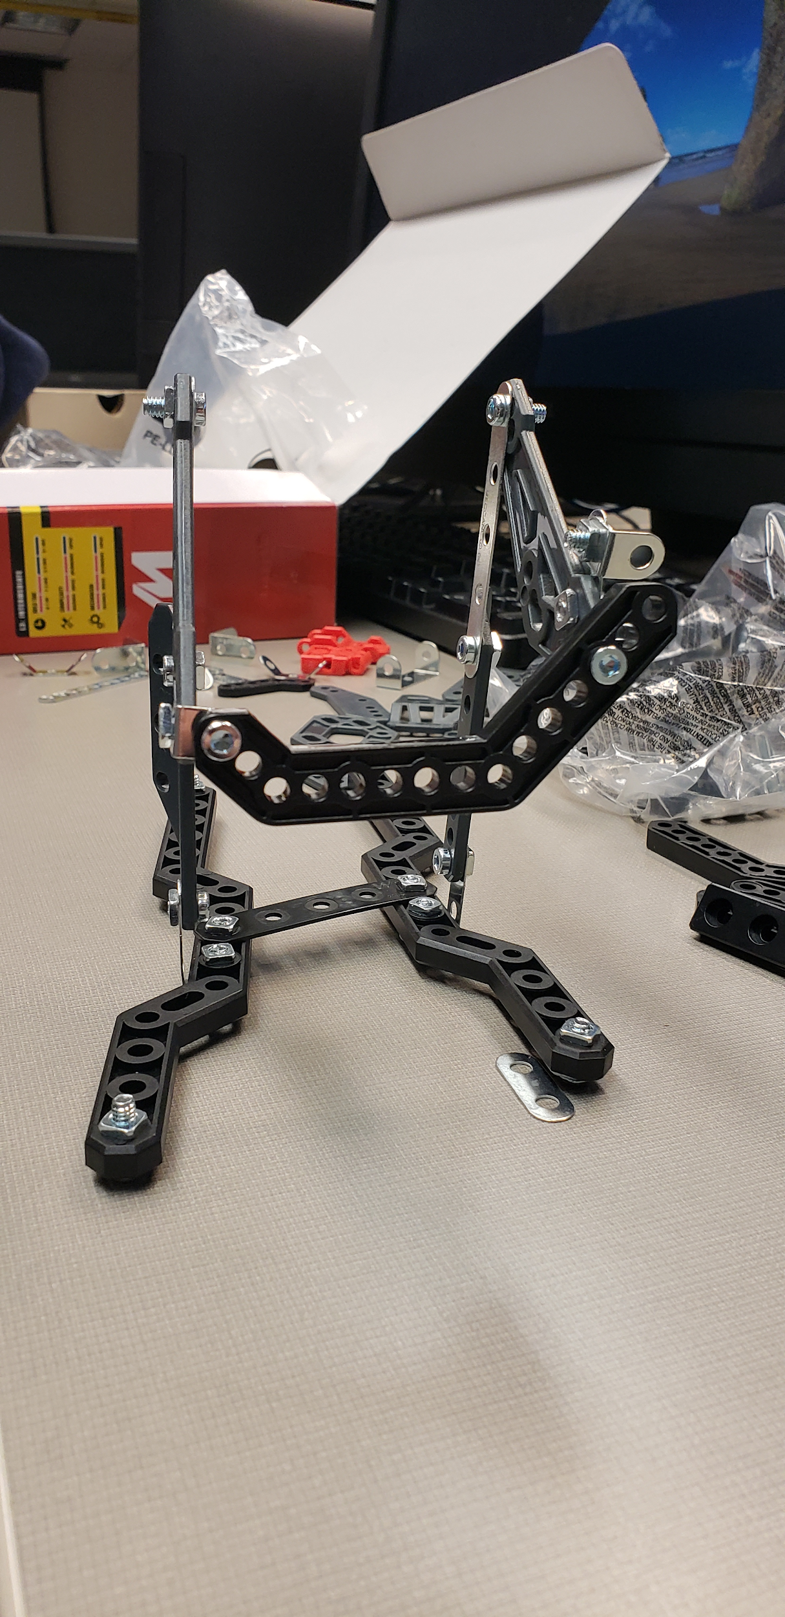

**Figure 4: Start of Structure Figure 5: Finished Structure**

**Section 4: Joints and motors**

Four servos, two for each eye, are utilized for the eye motion making it a joint to move about the X-axis in order to look left, right, and forward. A servo controlling the lower jaw makes the mouth joint which is used to make the head talk by opening and closing from moving the servos to certain angles. The eyebrows will be connected to one servo that raise and lower his eyebrows as one.

**Figure 6: Servo Motors** 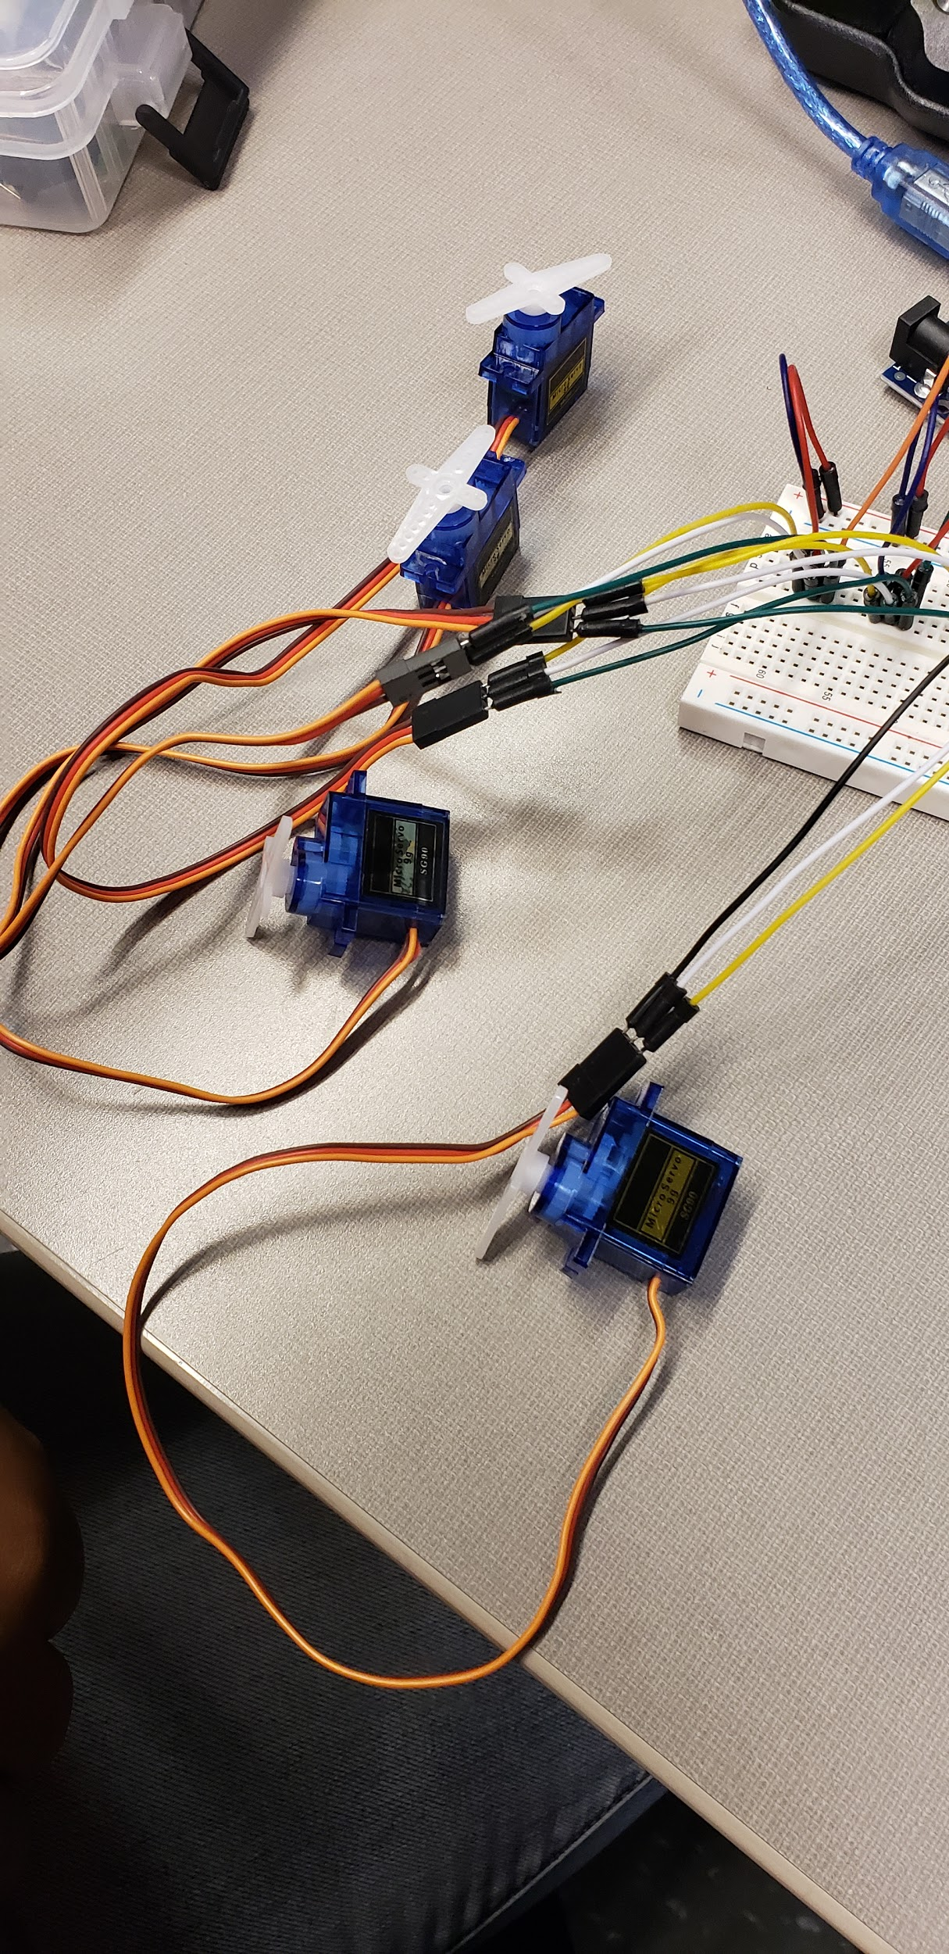

**Section 5: Sensors**

The sensors used include a ultrasonic sensor to initialize the mouth motion for the animatronic head to talk as well as for the eyes to look around. It will do this by sensing an object that is 60 centimeters away. A contact button placed on the nose, when depressed will engage the eyebrows to lift.

**Figure 7: Ultrasonic Sensor Figure 8: Button Sensor**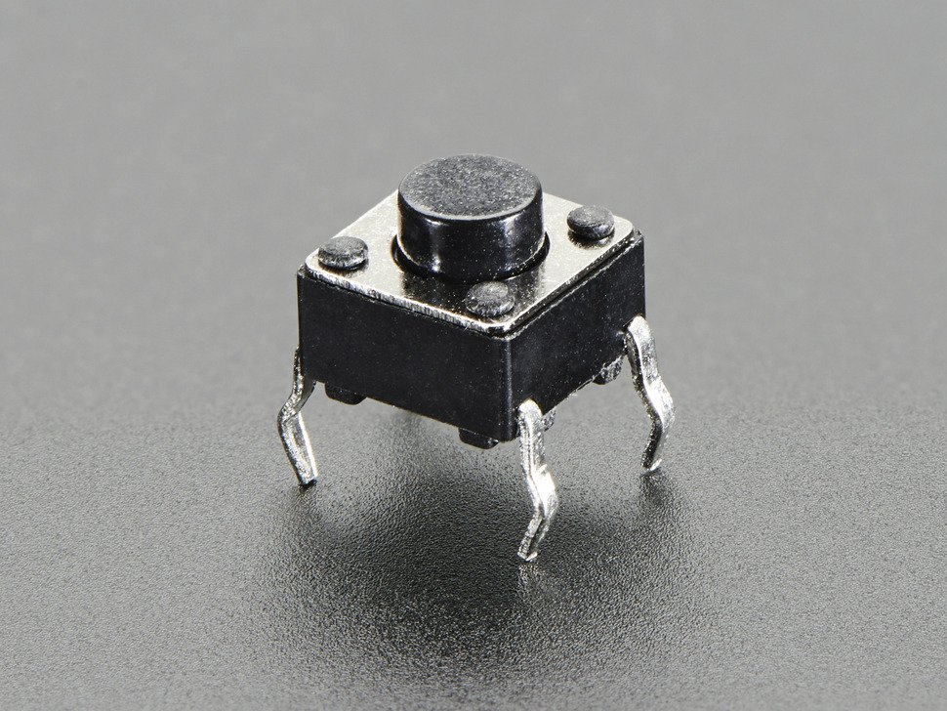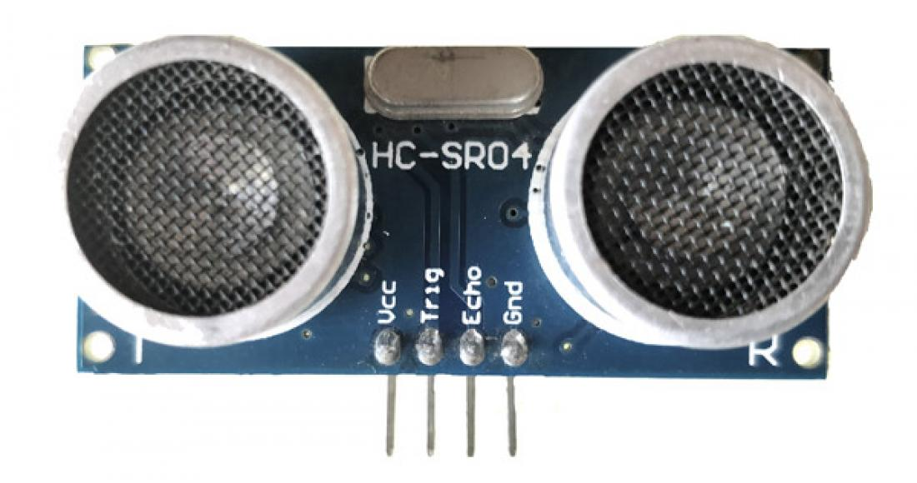

**Section 6: Programming for interaction**

The greatest difficulty we had for the interactive button was that we had to visualize the connections as though it was sitting on the actual breadboard. However, all pins were connected to the corresponding inputs such as the echo pin going into 10 since the ultrasonic radar sensor requires a PWM pin. All the servos were connected to digital pins on the Arduino Mega since they don’t require that same configuration as the ultrasonic sensor. For the push button, since the bottom of the orientation it was placed on is automatically a connected signal, those were placed as a series with the incoming pin 2 and the negative end of the resistor. The positive end of the resistor was connected to the ground also in series but parallel to the inputs. The top of the button legs were connected to the 5V on one leg since, again, they are automatically connected.

We used the “delay” feature to add a second in between mouth movements and add half a second for the eyebrows and eyes. However, we decided to connect the eyebrow movement to the button interaction only just so that the face would act almost surprised to being touched. This was done by implementing “if” “else” statement to ensure that when Button state was high (pressed) then it would react and also included an “||” as an or statement to simplify the reading of the code to the arduino. Thus, if the button was pressed but there was a person within 10cm of the ultrasonic sensor then the mouth would start moving and so would the eyes but the eyebrows only if button was pressed. We had to include a “cm” conversion from seconds to cm to better analyze the distance and easily say how far a person can be to get a response from the face.

**Section 7: Lessons learnt and suggestions**

**Lessons Learned**

1. Thinking about how joints would naturally move when assembling the erector set and adhering the mask/face.
2. Learning that certain adhesives work better than others when piecing together the animatronic head. Just hot gluing zip ties to the servo motors was rather ineffective, but super glue and hot glue seemed to provide a solution.
3. Trying to use the type of foam spheres for the eyes was more difficult than imagined when securing the eyes to the servos.
4. Figuring out the proper way to adhere a 2D print out of Dr.Wang’s face onto a 3D mask/structure.
5. Understanding the amount of load that the servo motor could handle to not overwhelm it.
6. Code may work for different sensors individually, but it has to be adjusted when integrated with multiple other sensors and motors.
7. It’s not as complicated as we made it seem.

**Ways to improve**

1. Using a pulley system would work better for the movement of the face, especially the eyes, by using a fishing line and attaching to the servos without needing much rotation.
2. Creating a base for the bottom of the eyes to avoid drooping and also add stability without damaging movement.
3. Assemble a stronger base to avoid shaky base.
4. Perhaps use a simpler and tougher material for structure.
5. Learn more about how to add sound instead of us clicking a button on the computer for a voice output.
6. Ping Pong balls seemed more efficient and practical for use of eyes.

**Section 8: Personnel and bill of materials**

**(a) Personnel**

|  |  |  |
| --- | --- | --- |
| Task | Main Personnel | Secondary personnel |
| Structure/ Chassis | Tiraja | Yisvi, Evangeline |
| Creating joints and motor interfacing | ALL |  |
| Overall programming and integration | Yisvi | Evangeline, Tiraja |
| Integrating sensors and interfacing sensors | Yisvi | Evangeline, Tiraja |
| Attaching image and adjusting the Animatronic accordingly | Evangeline | Tiraja, Yisvi |

**(b) Bill of materials**

|  |  |  |  |  |  |
| --- | --- | --- | --- | --- | --- |
| No. | Description | Website/comment | Qty. | Unit $ | Total $ |
| 1 | Arduino MEGA 2560 | Provided | 1 |  | -- |
| 2 | Erector Set | https://www.target.com/p/erector-by-meccano-super-car-road-racer-25-in-1-model-building-set/-/A-54197458 | 1 | 39.99 | 39.99 |
| 3 | Ultrasonic Sensor | provided | 1 |  | -- |
| 4 | servo motors | amazon.com | 5 |  | 12.99 |
| 5 | Button (Contact Sensor) | supply from past labs | 1 |  | -- |
| 6 | Mask | Hobby Lobby | 1 | 3.99 | 3.99 |
| 7 | Styrofoam Balls | Hobby Lobby | 1 | 3.29 | 3.29 |
| 8 | Zip Ties | office supply | 1 |  | -- |
| 9 | Electric Tape | home supply | 1 |  | -- |

The total price for this project excluding the Arduino MEGA was **$60.26**

**References:**

# [1] Animatronics Face of UTSA's President, Dr. Ricardo Romo, <https://youtu.be/xkze1_hnam0>

# [2] ROMOBOT - ANIMATRONIC FACE ROBOT

# <https://www.instructables.com/id/RomoBOT-Animatronic-Face-Robot/>

[3] Designing and Constructing an Animatronic Head Capable of Human Motion Programmed

using Face-Tracking Software

<https://web.wpi.edu/Pubs/ETD/Available/etd-050112-072212/unrestricted/Fitzpatrick.pdf>

[4] Talking Animatronic head

<https://www.instructables.com/id/Talking-Animatronic-Robot-Head/>

[5] Build a Robot Animatronic Face

<https://www.youtube.com/watch?v=mDe6q6RMUtY>

**Appendix A: Code**

#include <Servo.h>

Servo mouth; //servo1

Servo R_eye; //servo2

Servo L_eye;

Servo R_eyebrow;

Servo L_eyebrow;

int buttonPin = 2; //activating pin 2 for Push Button

int buttonState = 0; //variable for Push Button

int trigPin = 9;

int echoPin = 10;

long distance;

long duration;

void setup() {

Serial.begin(9600); //activating Serial Monitor

mouth.attach(43); //activating pin 9 for servo1

R_eye.attach(46); //activating pin 11 for servo2

L_eye.attach(53);

R_eyebrow.attach(52);

L_eyebrow.attach(47);

pinMode(echoPin , INPUT);

pinMode(trigPin, OUTPUT);

pinMode(buttonPin , INPUT); //setting Push Button as an input

}

void loop() {

buttonState = digitalRead(buttonPin); //reading buttonPin and storing it as buttonState.

Serial.println(buttonState); //telling computer to print buttonState.

if (buttonState == HIGH || distance <= 10){ //if button is pressed...

mouth.write(90);

delay(1000);

mouth.write(180);

delay(1000);

mouth.write(90);

delay(1000);

mouth.write(180);

delay(1000);

mouth.write(90);

delay(1000);

//mouth.detach();

delay(1000); //wait one second

R_eye.write(90); //setting servo1 to 10 degrees

L_eye.write(70); //setting servo2 to 170 degrees

R_eyebrow.write(180);

L_eyebrow.write(180);

digitalWrite(trigPin, LOW);

delayMicroseconds(2);

digitalWrite(trigPin, HIGH);

delayMicroseconds(10);

digitalWrite(trigPin, LOW);

duration = pulseIn(echoPin, HIGH);

distance = duration*0.034/2;

}

}

**Appendix B: Arduino wiring**

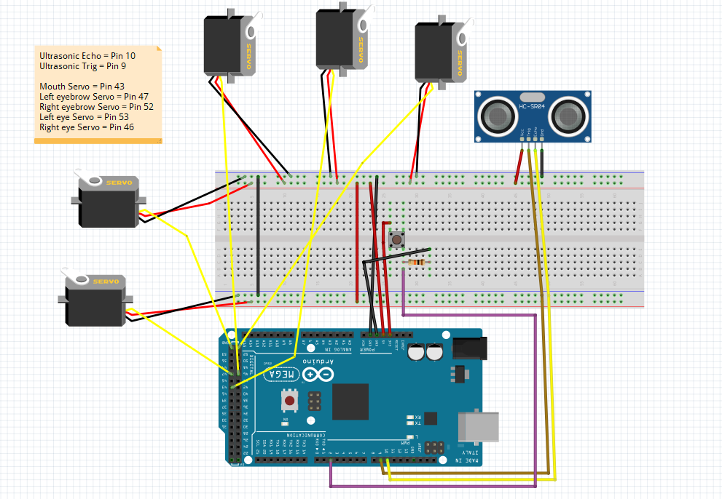

**Appendix C: Example Codes for push button and ultrasonic sensor**

1. // defines pins numbers
2. const int trigPin = 9;
3. const int echoPin = 10;
4. // defines variables
5. long duration;
6. int distance;
7. **void** setup() {
8. pinMode(trigPin, OUTPUT); // Sets the trigPin as an Output
9. pinMode(echoPin, INPUT); // Sets the echoPin as an Input
10. Serial.begin(9600); // Starts the serial communication
11. }
12. **void** loop() {
13. // Clears the trigPin
14. digitalWrite(trigPin, LOW);
15. delayMicroseconds(2);
16. // Sets the trigPin on HIGH state for 10 micro seconds
17. digitalWrite(trigPin, HIGH);
18. delayMicroseconds(10);
19. digitalWrite(trigPin, LOW);
20. // Reads the echoPin, returns the sound wave travel time in microseconds
21. duration = pulseIn(echoPin, HIGH);
22. // Calculating the distance
23. distance= duration*0.034/2;
24. // Prints the distance on the Serial Monitor
25. Serial.print("Distance: ");
26. Serial.println(distance);
27. }

const int buttonPin = 2; // the number of the pushbutton pin  
const int ledPin = 13; // the number of the   
  
// variables will change:  
int buttonState = 0; // variable for reading the pushbutton status  
  
void setup() {  
 // initialize the LED pin as an output:  
 pinMode(ledPin, OUTPUT);  
 // initialize the pushbutton pin as an input:  
 pinMode(buttonPin, INPUT);  
}  
  
void loop() {  
 // read the state of the pushbutton value:  
 buttonState = digitalRead(buttonPin);  
  
 // check if the pushbutton is pressed. If it is, the buttonState is HIGH:  
 if (buttonState == HIGH) {  
 // turn LED on:  
 digitalWrite(ledPin, HIGH);  
 } else {  
 // turn LED off:  
 digitalWrite(ledPin, LOW);  
 }